**5% discount on orders of 7 cases or more.  
Suggested retail price $1.95 each**

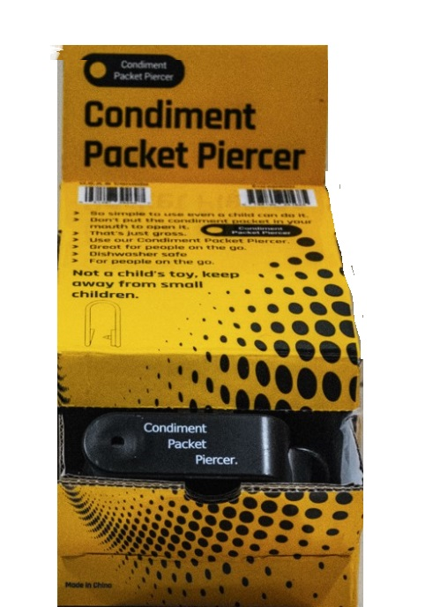

Slope Display, 6 per case.

144 total units.

$149.95 per case.

Slope product number 1002

**5% discount on orders of 7 cases or more.  
Suggested retail price $1.95 each**

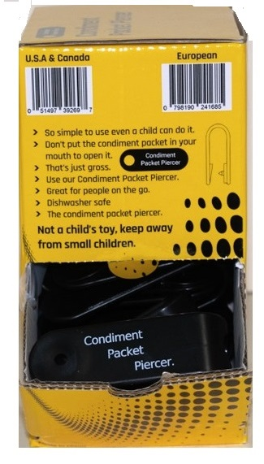

Tower Display, 6 per case.

$149.95 per case.

144 units per case

Tower product number 1001

**5% discount on orders of 7 cases or more.  
Suggested retail price $1.95 each**

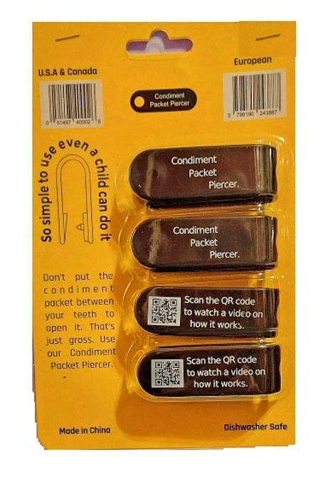  
Wall Hanger Display 24 per case.

$95.95 per case.

96 units per case.

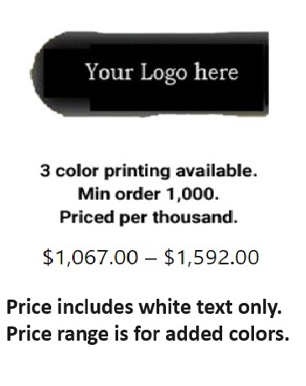

Comes with one point-of-sale display box per case.

